**Task E**

题目要求根据文本的评论的特定质量描述符, 和评级相关联, 挖掘其中是否有深层次信息. 为此本文通过对review_body的具体内容进行挖掘, 提取其相关描述信息, 并通过统计和绘图等方式进行了挖掘.具体步骤如下:

According to the specific quality descriptors of the text comments, the topic is required to be associated with the rating to find out whether there is deep-seated information. Therefore, this paper digs the specific content of the review body, extracts its related description information, and digs it by means of statistics and drawing. The specific steps are as follows:

1. 建立特定的质量描述符词典. 通过查阅资料和相关数据, 本文建立了用户情感-评论-程度词典, 词典中包含英文的各种描述情感、评论词汇、程度词汇等等, 具体词汇表见附录.

1. Establish a specific dictionary of quality descriptors. By consulting materials and relevant data, this paper establishes a user emotion comment degree dictionary, which contains a variety of English description emotions, comment words, degree words and so on. See the appendix for the specific vocabulary

2.将吹风机, 微波炉, 尿不湿数据合并, 同时提取review_body内容. 按用户评级分类, 分别从review_body中统计出现在词典中的词语, 通过词频统计方法得到各个词语出现的频次, 将结果按频次降序排列后取出前20个词语. 得到如下表格xxx:

2. Combine the data of hair dryer, microwave and pacifier, extract the content of review body. According to the classification of user rating, count the words appearing in the dictionary from review body, and get the frequency of each word through the word frequency statistical method. Arrange the results in descending order, and then take out the first 20 words. The following table XXX is obtained:

|  |  |  |  |  |  |
| --- | --- | --- | --- | --- | --- |
|  | 1 | 2 | 3 | 4 | 5 |
|  |  |  |  |  |  |
| old | 272 | 225 | 353 | 677 | 2512 |
| never | 298 | 0 | 0 | 0 | 0 |
| long | 241 | 186 | 327 | 563 | 1392 |
| new | 286 | 0 | 0 | 0 | 0 |
| good | 392 | 368 | 591 | 1402 | 3058 |
| much | 228 | 234 | 370 | 606 | 2079 |
| back | 460 | 212 | 0 | 0 | 0 |
| bad | 222 | 0 | 0 | 0 | 0 |
| high | 0 | 0 | 232 | 0 | 0 |
| however | 0 | 0 | 265 | 0 | 0 |
| need | 230 | 157 | 252 | 566 | 1645 |
| receive | 222 | 0 | 0 | 0 | 0 |
| keep | 0 | 196 | 261 | 479 | 1695 |
| cute | 0 | 0 | 0 | 0 | 1479 |
| perfect | 0 | 0 | 0 | 0 | 1600 |
| star | 0 | 0 | 0 | 440 | 0 |
| hot | 0 | 187 | 0 | 0 | 0 |
| easy | 0 | 0 | 0 | 832 | 3261 |
| dry | 386 | 326 | 535 | 1108 | 3578 |
| n't | 1509 | 1102 | 1594 | 2445 | 5932 |
| really | 237 | 268 | 417 | 784 | 2209 |
| want | 255 | 157 | 274 | 437 | 0 |
| love | 0 | 159 | 359 | 1184 | 8867 |
| great | 221 | 237 | 388 | 1405 | 5797 |
| nice | 0 | 0 | 0 | 558 | 1405 |
| small | 0 | 165 | 279 | 549 | 0 |
| like | 642 | 602 | 984 | 1851 | 4186 |
| best | 0 | 0 | 0 | 0 | 1448 |
| even | 401 | 208 | 233 | 0 | 0 |
| first | 355 | 223 | 0 | 0 | 1363 |
| still | 228 | 0 | 255 | 506 | 0 |
| set | 0 | 163 | 272 | 607 | 1378 |
| well | 285 | 302 | 531 | 1019 | 2932 |

利用表格数据绘制热力图(图xxx)进行直观分析.

Use table data to draw thermodynamic diagram (Figure XXX) for intuitive analysis.

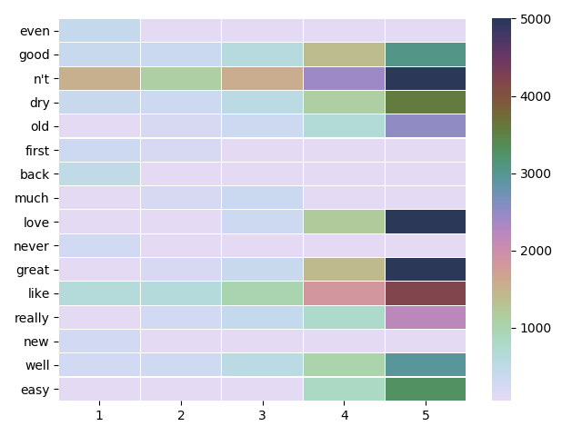

图中横坐标为星级, 纵坐标为单词, 从图和表中可以看出, 评分为一星的评价出现的单词最多的是” n’t ”是个否定词, 出现了1509次, 接下来的是never, like等; 而评分为5星的出现最多的单词为love(8867次), 其次为great, like等等, 该单词在一星或二星中几乎未出现. 这表明特定的描述词汇与评级是密切相关联的. 同时, 我们也注意到了, “ n’t ”在各个星级中都出现了多次. 通过具体的review_body数据分析, 在一星级中其多与其他积极词汇同时出现用以表达否定情感, 例如” n’t like ” 等等. 而在五星数据中其常形成许多积极情感的短语, 例如” like n’t allow finger print”等等.

In the figure, the abscissa is the star_rating, and the ordinate is the word. From the figure and table, it can be seen that "n't" is a negative word, which appears 1509 times in review_body of five stars , followed by never, like, etc.; while the word with 5 stars is love (8867 times), followed by great, like, etc, These words hardly appears in one or two stars. This shows that specific description words are closely related to rating. At the same time, we also notice that "n't" appears many times in all stars. Through specific review body data analysis, in one star, many of them appear at the same time with other positive words to express negative emotions, For example, "n't like" and so on. In five-star data, it often forms many positive emotional phrases, such as "like n't allow finger print" and so on.

通过上述分析, 我们总结出如下的星级常用词汇表xxx:

Based on the above analysis, we summarize the following common star vocabulary XXX:

|  |  |  |  |  |  |
| --- | --- | --- | --- | --- | --- |
| 1 | 2 | 3 | 4 | 5 | |
| not like | not good | not like | like | love |
| never | not like | not good | well | great |
| back | old | much | great | easy |
| even | not well | old | not | like |
| bad | dry | however | need | well |